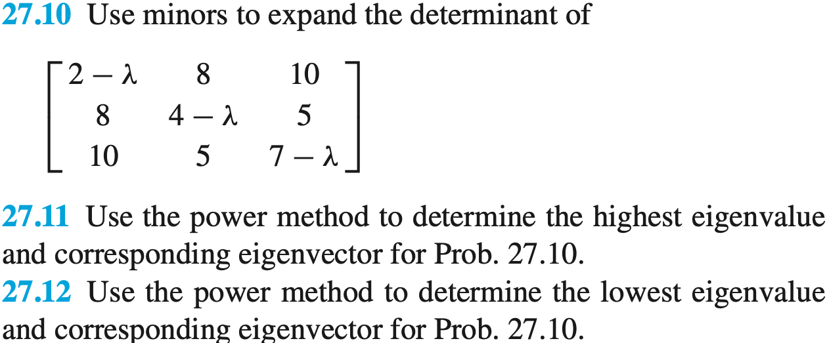

I decided to find all Eigenvalues first. I used the rule of Sarrus to find the determinants of the matrix. My work is in page 1 of the scanned documents.

I ended with the equation $γ^{3}-13γ^{2}-139γ+42=0$

Finally, I used the bisection method to find the roots of this equation. The work is in the excel file.

**The Eigenvalues are: -7.17848, 0.29424, and 19.88423.**

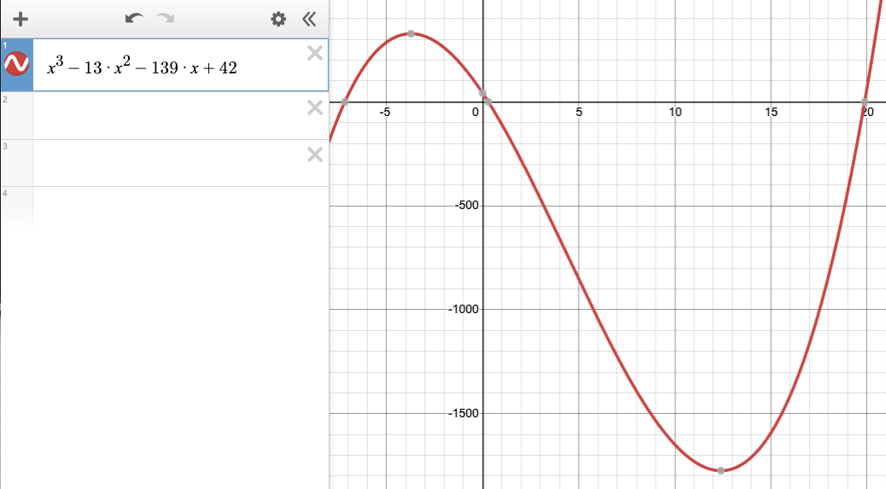

Excel does not have an intrinsic matrix tool so I used a matrix calculator online to do the power calculations: https://matrixcalc.org/en/

Here are the iterations for the matrix multiplication and optimization of the Eigenvalue calculation. The iterations are in reverse order with the highest Eigenvalue calculation in the left column and the lowest Eigenvalue calculation in the right column. The calculation of the inverse of the matrix for the lowest Eigenvalue calculation is in the bottom of the left column.

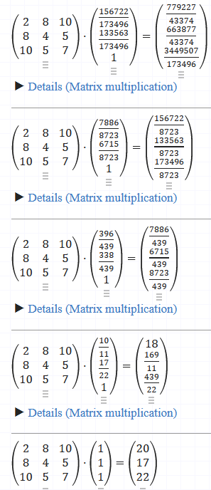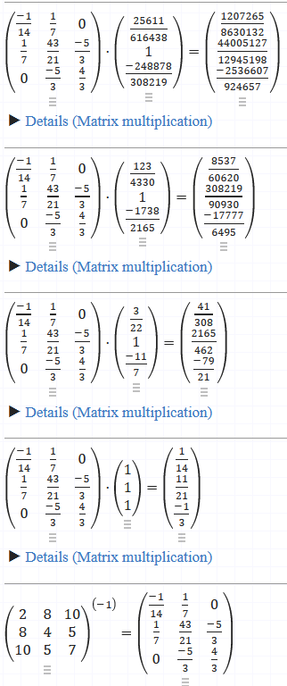

I used Gaussian elimination to find the vectors for the high and low Eigenvectors. The calculations are in the excel file. The Eigenvector calculations are in the scans of the hand calculations.

The power method returned the lowest Eigenvalue of 0.294 which is the lowest by absolute value. The matrix unraveling produced a negative Eigenvalue.

Answers are

$$γhighest=19.882 γlowest=0.294$$

For X3=1

$$Vγhighest=\left({0.904 \atop \begin{aligned}0.770 \\ 1\end{aligned}}\right) Vγlowest=\left({-0.051 \atop \begin{aligned}-1.239 \\ 1\end{aligned}}\right)$$